**Configuring S3 Stage in Jenkins Pipeline**

## Setup S3 Bucket for Static Website

1. **Unblock Public access**
2. **Add Bucket Poilicy**

**{**

**"Version": "2012-10-17",**

**"Statement": [**

**{**

**"Effect": "Allow",**

**"Principal": "*",**

**"Action": [**

**"s3:GetObject"**

**],**

**"Resource": "arn:aws:s3:::ps-bookmyhotel-testing-fe-s3/*"**

**}**

**]**

**}**

1. **Enable Static Web Site Hosting**

## Jenkins Plugin



**Create Jenkins User**

**Attach policy AmazonS3FullAccess**

**Create Access Keys for Jenkinsuser**

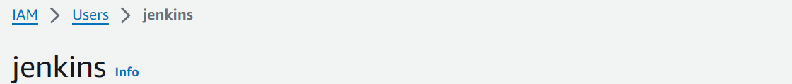

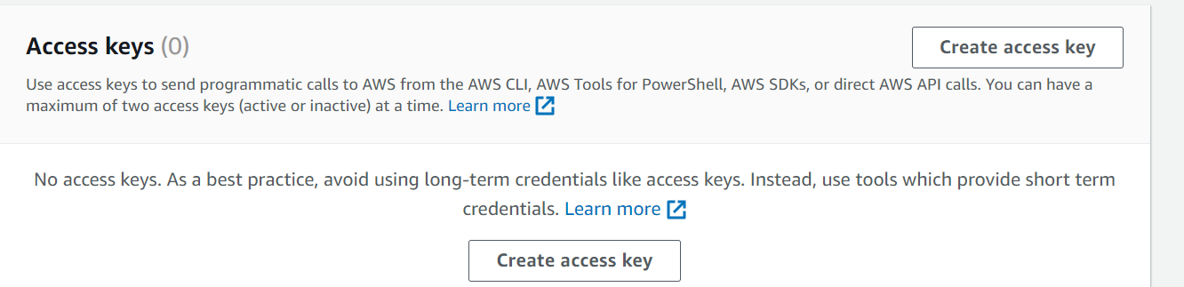

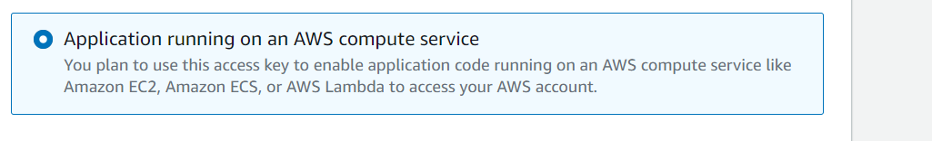

**Download .csv file with Access Keys.**

**Setup Credentials in Jenkins**



